Base 11.2.0

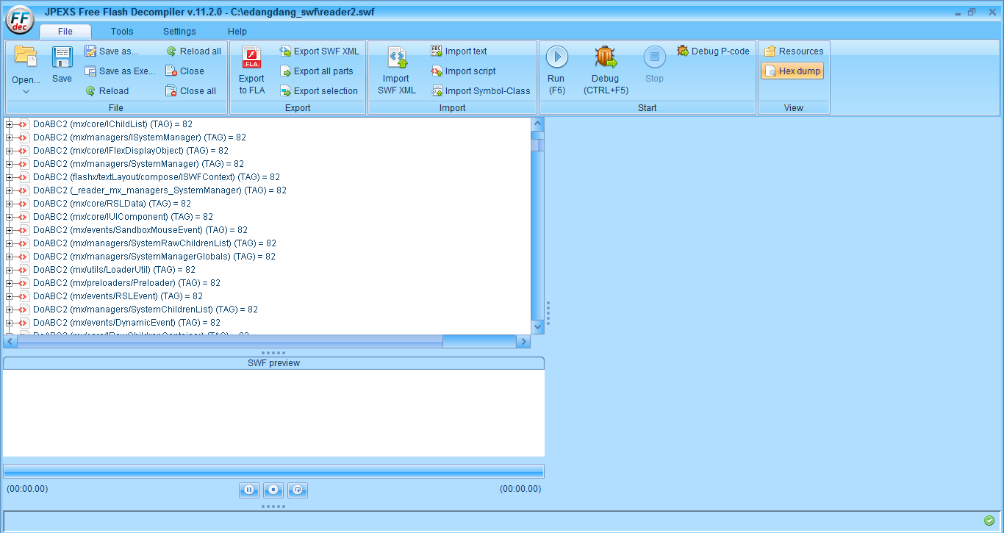

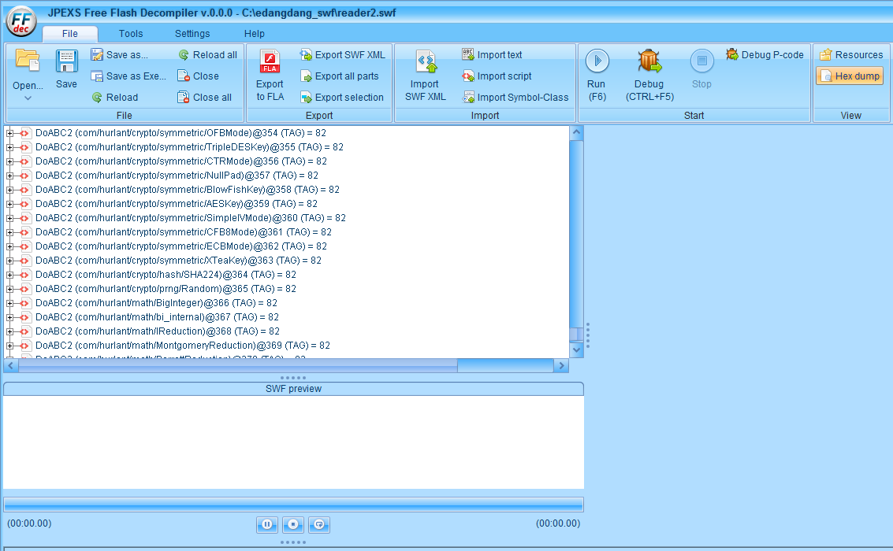

Mainly modify SWFInputStream.java(D:\github\jpexs-decompiler\libsrc\ffdec_lib\src\com\jpexs\decompiler\flash\SWFInputStream.java)

1. add public variant
2. modify di.nam

tagindex0=tagindex0+1;

di.name=tag.getName() +"@"+tagindex0;